Ex1 :

A )

> **ec1:=diff(x(t),t)=-k*x(t);**



> **cond_in:=x(0)=x0;**



> **sol1:=dsolve({ec1,cond_in},{x(t)});**



> **xx:=unapply(rhs(sol1),t,x0,k);**



> **plot(xx(t,10,2),t=0..15);**

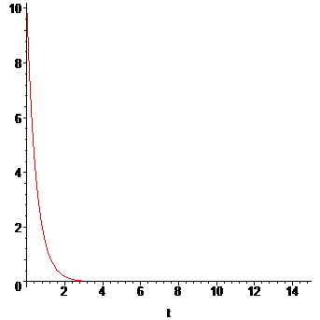

C)

> > **ec2:=xx(5730,x0,k)=x0/2;**



> **kC14:=solve(ec2,k);**



> **evalf(kC14);**



D)

> **ec3:=xx(T,100,kC14)=20;**



> **Te:=solve(ec3,T);**



> **evalf(Te);**



E)

> **ec4:=xx(T,100,kC14)=91.57;**



> **Te1:=solve(ec4,T);**



> **ec5:=xx(T,100,kC14)=91.021;**



> **Te2:=solve(ec5,T);**



Ex2:

A )_ B )

> **ecc1:=diff(T(t),t)=-k*(T(t)-Tm);**



> **cond_in2:=T(0)=To;**



> **soll2:=dsolve({ecc1,cond_in2},{T(t)});**



> **xx2:=unapply(rhs(soll2),t,To,Tm,k);**



> **plot(xx2(t,20,10,0.5),t=0..50);**

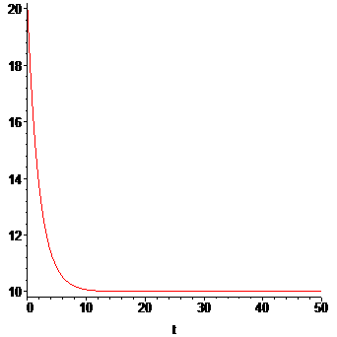

C)

> **ecc2:=xx2(td,36,21,k)=34.22;**



> **ecc3:=xx2(td+1,36,21,k)=34.11;**



> **solve({ecc2,ecc3},{k,td});**



Ex3 :

A )

> **ec1:=diff(v(x),x)=-(g*R^2)/((x+R)^2*v(x));**



> **cond_in3:=v(0)=vo;**



> **sol3:=dsolve({ec1,cond_in3},{v(x)});**



> **xx3:=unapply(rhs(sol3[1]),g,R,x,vo);**

